Offering Song: Canticle of the Turning (Rory Cooney)
This evening’s offering will support the works of mercy of the participating churches.

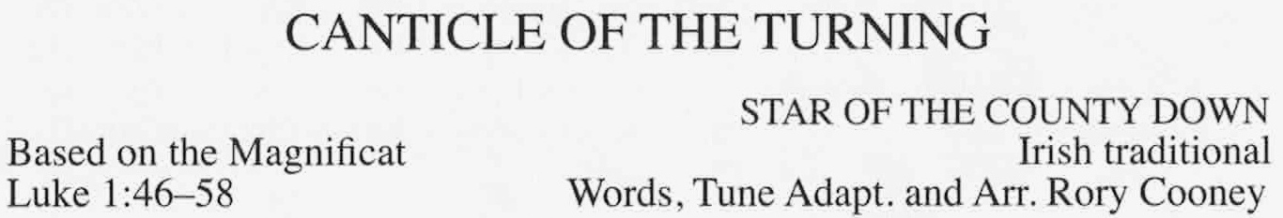
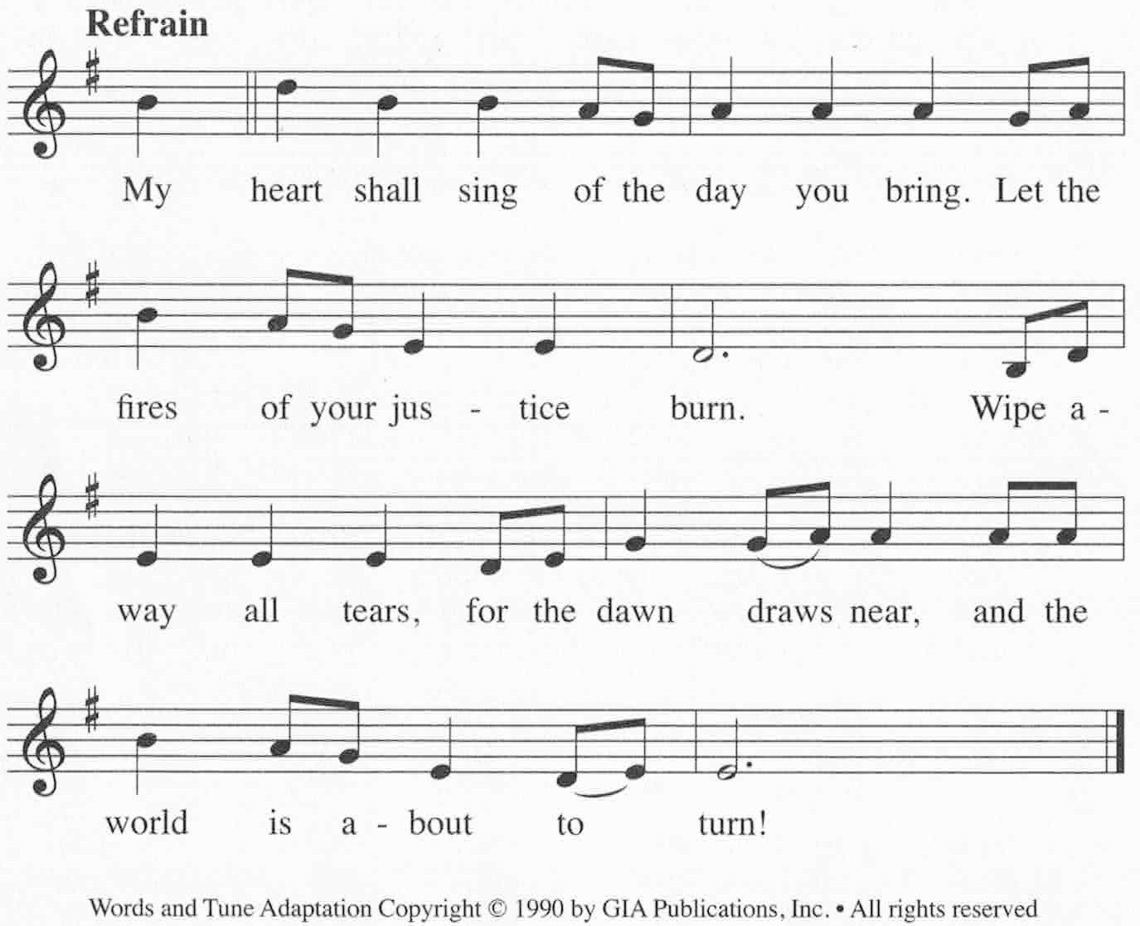

Intercessory Prayer

Lord’s Prayer

Blessing and Dismissal

Recessional Hymn: Now Thank We All Our God #603

Thank you to the Pastors and Music Ministers
of our communities
for guiding us this evening and throughout the year!

Now Thank We All Our God

With Heart
and Hands
and Voices

Ecumenical Thanksgiving Prayer
November 22, 2016
Order of Worship
Processional Hymn: We Gather Together #762

Ministers process in

Call to Worship

The Exodus Story (cf. Ex 14:15 – 15:1) Assembly Responses Below

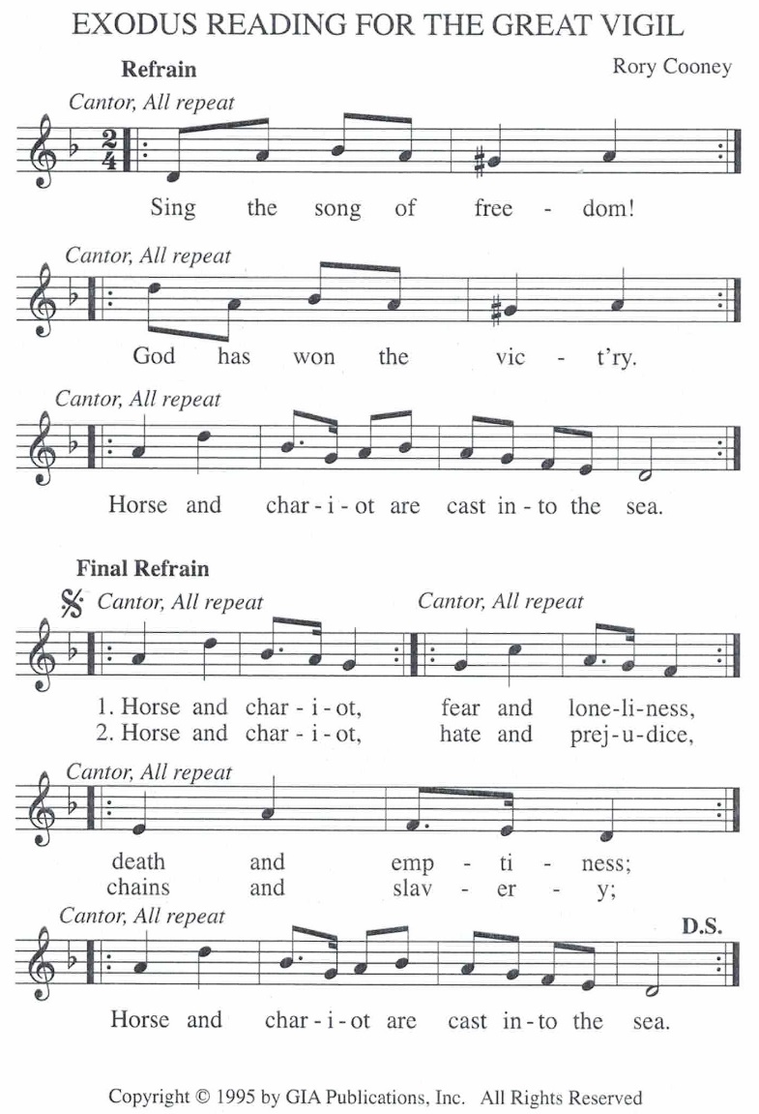

Cantor intones: The Word of the Lord
All respond: Thanks Be to God

Please stand for prayer.

Reading: Philippians 4:1,4-14

Alleluia (Please stand and repeat Alleluia after the cantor)

Gospel: Luke 10:38 – 42

Homily

All That We Have Gary Ault

R. All that we have and all that we offer comes from a heart both frightened and free. Take what we bring now and give what we need, all done in his name.

- Some would rely on their power, others put trust in their gold. Some have only their Savior, whose faithfulness never grows old (refrain)
- Sometimes the road may be lonesome, often we may lose our way; take courage and always remember love isn’t just for a day (refrain)
- Sometimes when troubles are many, life can seem empty it’s true, but look at the life of the master who lovingly suffered for you (refrain)

Reflection Song: Halleluiah (words, Kelley Mooney; music, Leonard Cohen)

Sharing of Peace

