Offering Song: Canticle of the Turning (Rory Cooney)
This evening’s offering will support the works of mercy of the participating churches.

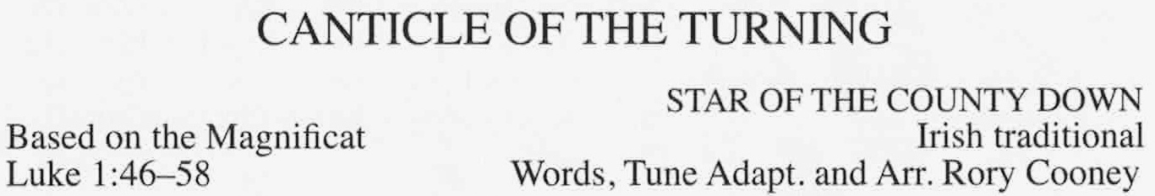
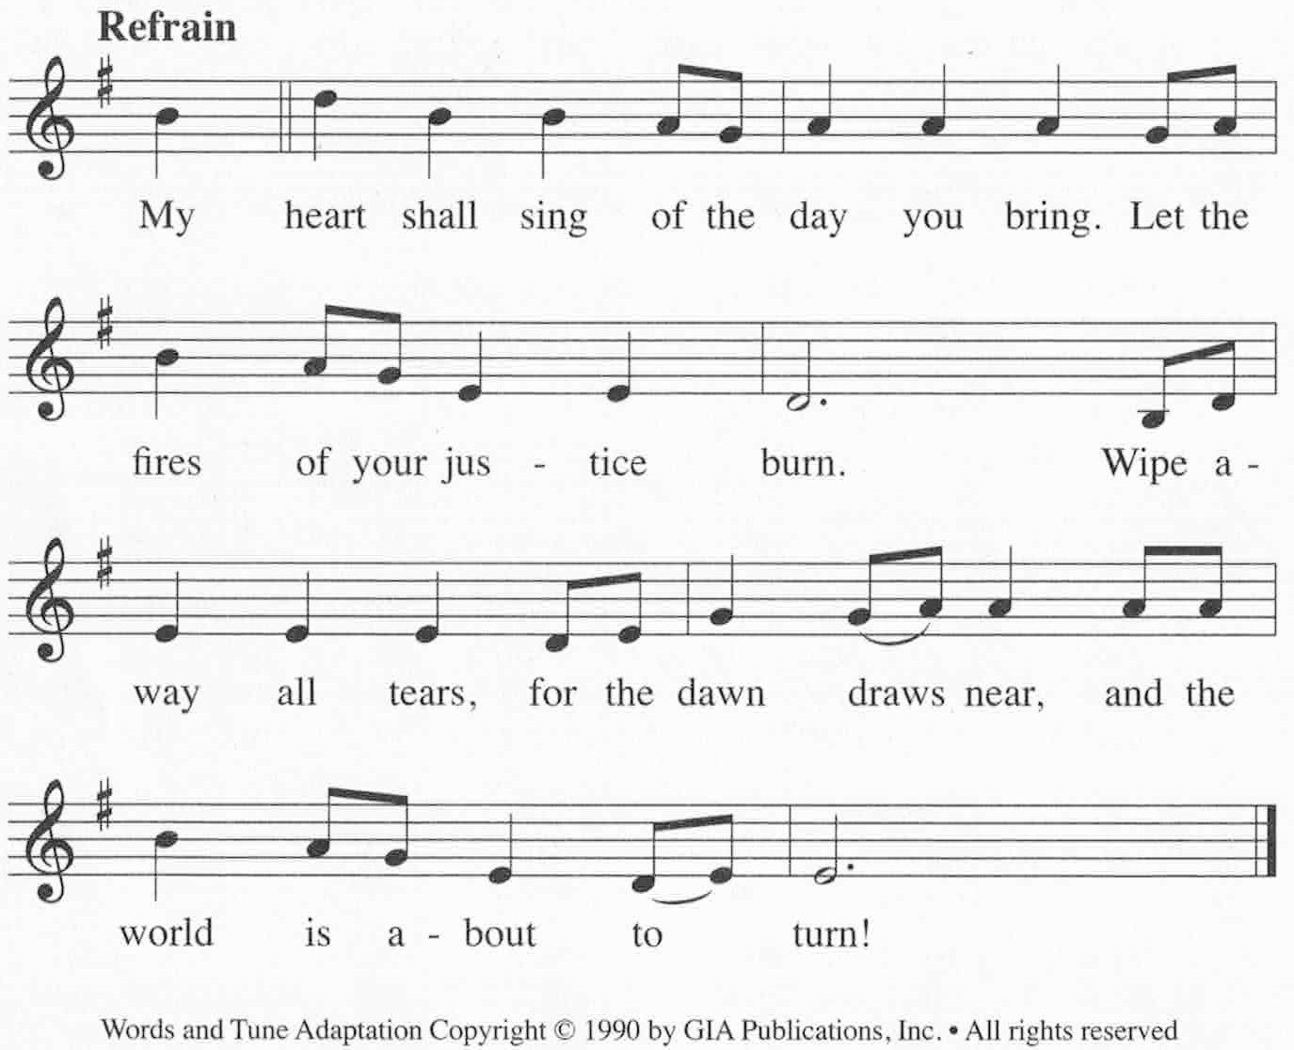

Intercessory Prayer

Lord’s Prayer

Blessing and Dismissal

Recessional Hymn: Now Thank We All Our God #603

Thank you to the Pastors and Music Ministers
of our communities
for guiding us this evening and throughout the year!

Now Thank We All Our God



With Heart
athe life of the master who lovingly suffered for you (

